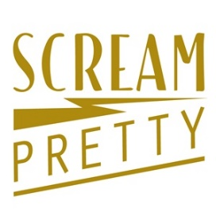
Scream Pretty Image Usage Terms For Trade Customers – April 2021

We have updated these terms of use to ensure that IP rights are not infringed for the protection of all parties

By accessing the images in this shared folder you agree to the following terms

- Approved white cut out and lifestyle model images available from within this folder are made available for royalty-free use on trade customers owned websites and social media feeds

- If these approved images are used exclusively in any post on your social media accounts then you must reference Scream Pretty in the copy

- Where Scream Pretty products/images are promoted in the press then they must be credited to Scream Pretty via your Shop/Business Name. ie Silver Sparkling Huggie Hoops by Scream Pretty @ [your shop name/web address]

- Additional lifestyle model images from our website cannot be used for Press and public relations including influencer marketing, social media and advertising purposes without the explicit written permission from Scream Pretty.

- If images are used without consent or authorisation for press and advertising purposes - we may charge a fee for use of Intellectual property use of up to £10,000 per image

